# Deze samenvatting behandelt alleen globale punten , op de laatste dia’s staan summary quiz + samenvatting dies ook handig

# Lessons 1.1:

Data is defined as a representation of facts, concepts, or instructions in a formalized manner

Information 🡪 is the processed data

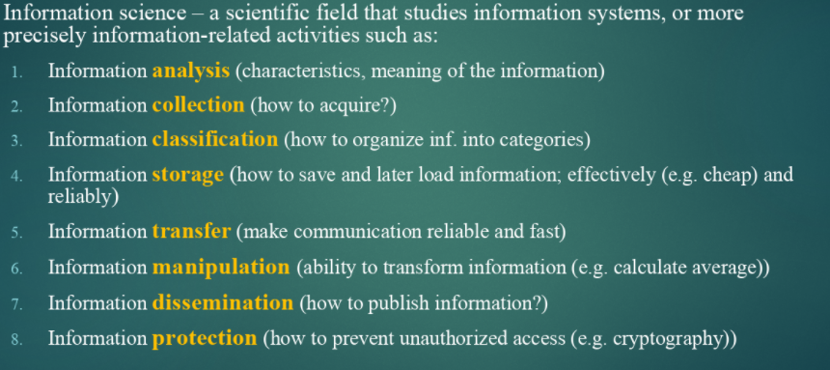

Informatics is an applied form of information science 🡪 involves: information processing and engineering of information systems

Computer science is a set of skills and knowledge about technologies focusing on development, programming and use of computers 🡪 Deals with all practical activities related to information

Computer 🡪 manipulates information or data

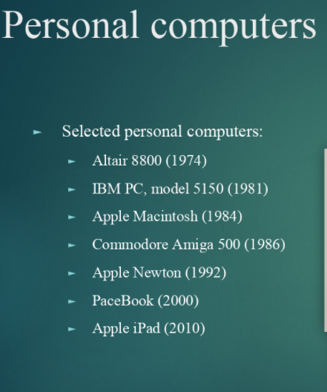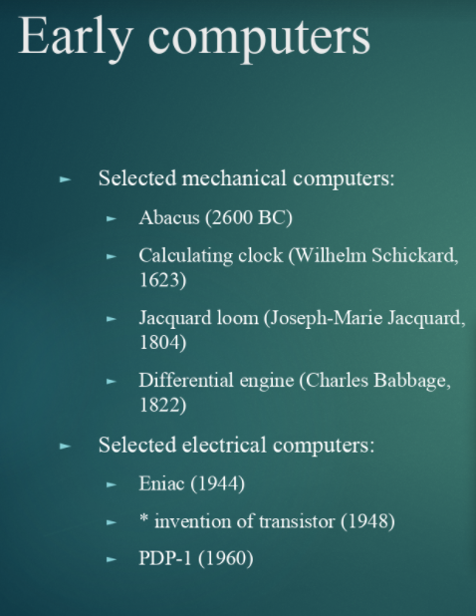

Computer 🡪 fundamental operations:

1. Input 🡪 take information
2. Storage 🡪 store information
3. Processing 🡪 process information
4. Output 🡪 give results

Fixed progam computer 🡪 computer that is desgined to do very specific things only like calculating

Stored-program computer 🡪 stores (and manipluates) a sequence of instructions , and has a set of elements that will execute any instruction in that sequence

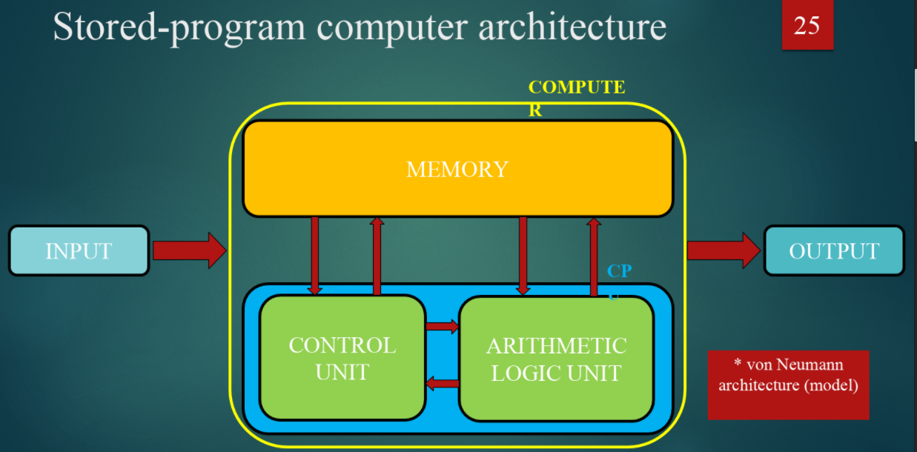

Every computer consists of Hardware and Software

Hardware:

* CPU
* Motherboard
* Keyboard
* Mouse
* Etc

Software:

1. Set of instructions, data or prgrams used to operate computers and specific tasks
2. Software is a generic term to refer to applications, scripts and programs that run on a device

System software 🡪 is a type of computer program that is designed to run a computer’s hardware and application programs

Programming software 🡪 is a program that helps programmer in developing other software

Application softwarte 🡪 a collection of programs used by end users + a software developed to epp user perform a specific task

Analog 🡪 continuous signal

Digital 🡪 sequence of 1’s and 0’s

Analog can always be converted to digital, but quality goes down

Digital is more precise but is limited by memory etc

# Lesson 1.2

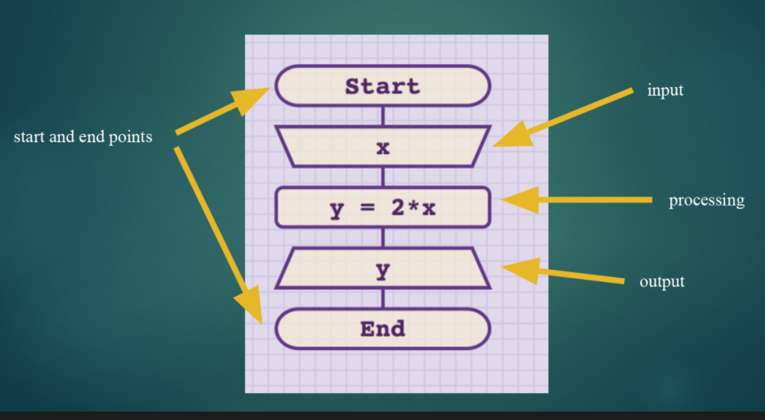

Rest is gewoon +, - , % etc

# Lesson 2.1

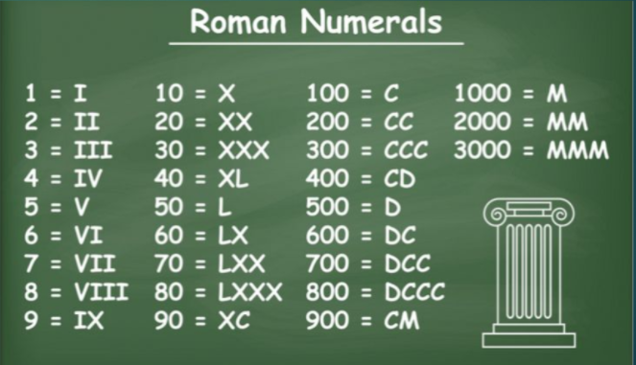

Numeral systems -🡪 1: NON positional numeral systems , 2: positional numeral systems

Binair rekenen: (voor op toets herken t als n klein tweetje onder t getal op t einde)

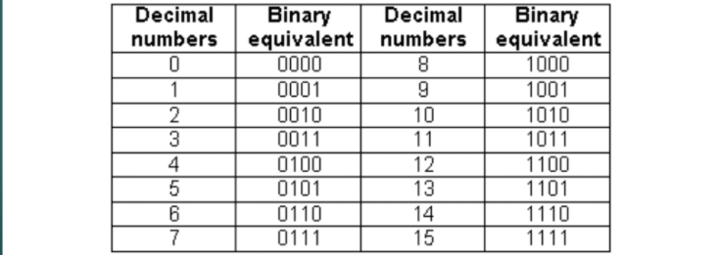

Hexadecimaal

1,2,3,4,5,6,7,8,9,A,B,C,D,E,F

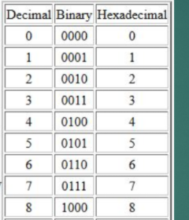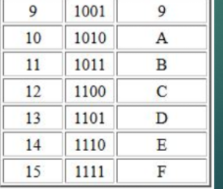

711 decimaal is bijvoorbeeld 2C7 in hexadecimaal want

(2 * 16*16) + (16*12) + (7)  
Herkennen:  
Binair is getal met klein 2tje onderaan  
hexadecimaal is getal met klein 16 onderaan  
decimaal dus normaal getal is met kleine 10

# Lesson 2.2

Gaat puur over variablen

A variable name 🡪 can be any length and can consist of uppercase and lowercase letters, digits, underscore

# Lesson 3.1 Boolean

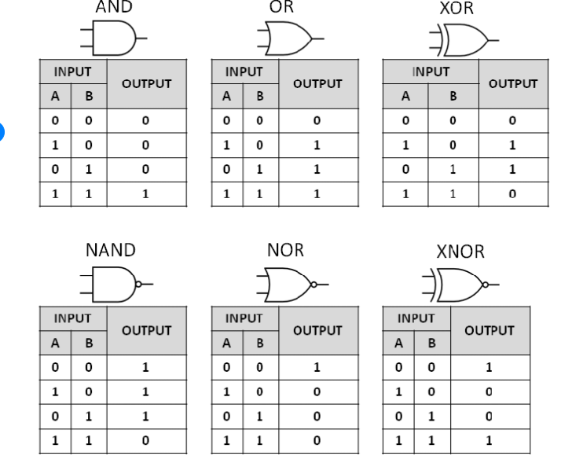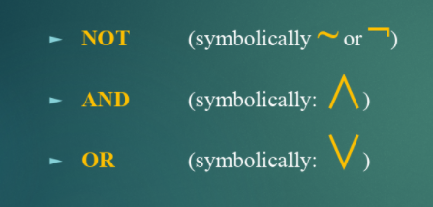

**IMPLICATIOn symbool: 🡪 betekend “ IF p THEN q”**

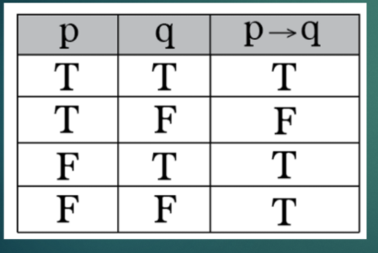  
**BICONDITIONAL symboo: 🡨🡪 if and only if p ten q**

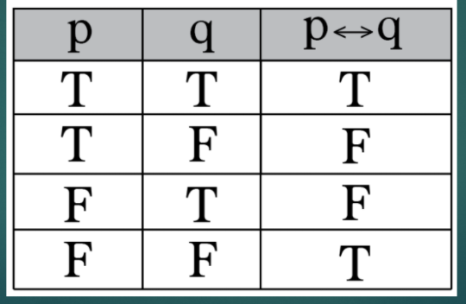

# Lesson 3.2 Boolean

Boolean gebruiken in python 🡪 True, False, And, Or, Not etc

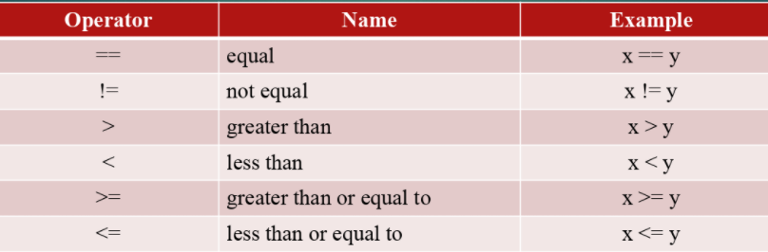

# Lesson 4.1 Logic

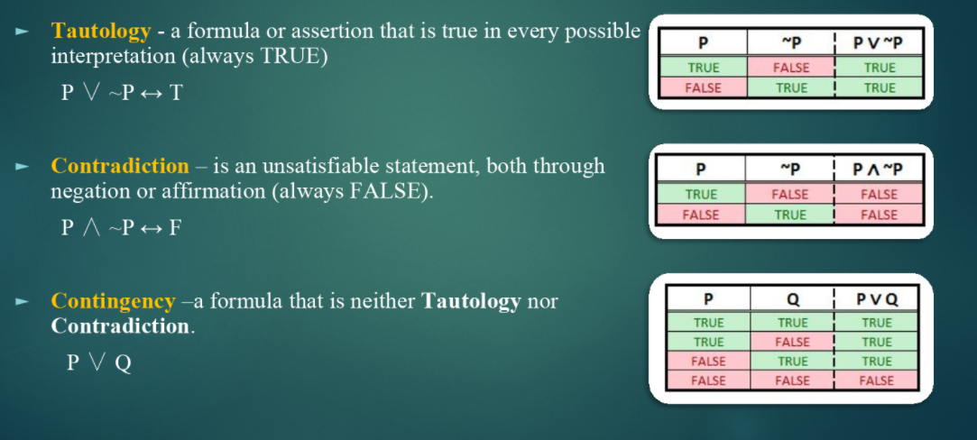

Morgan’s law 🡪 describes how mathematical statements and concepts are related through their opposites

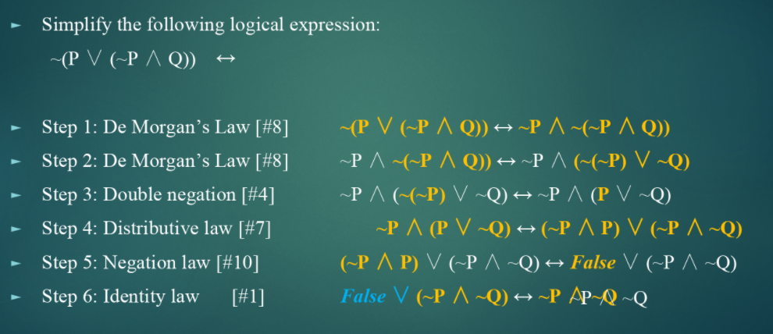

Rewriting:  
not ( x>= 0) kan ook als x<0

Deductive reasoning logic 🡪 is the process of reasoning from one or more statements to reach logically certain conclusion

Voorbeeld:

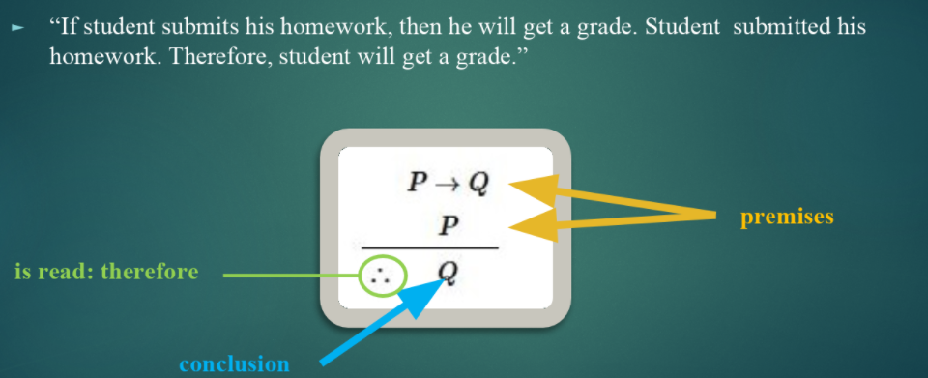

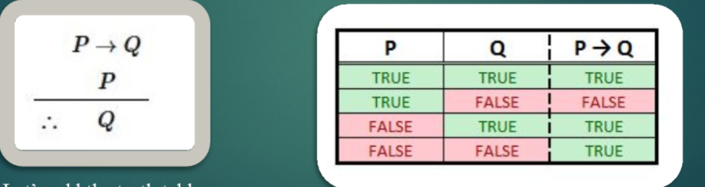

Tekens herkennen / namen :  
^ 🡪 logical conjuction ∨ 🡪 logical disjunction  
¬ / ˜🡪 negation (beide zelfde betekenis) ↔ 🡪 material equivalence  
(🡪 draait om pijl ) 🡪 material implication

# Lesson 4.2 Cyclic algorithms

While loops en for loops

# Lesson 5.1 sets

Set = well defined collection of objections

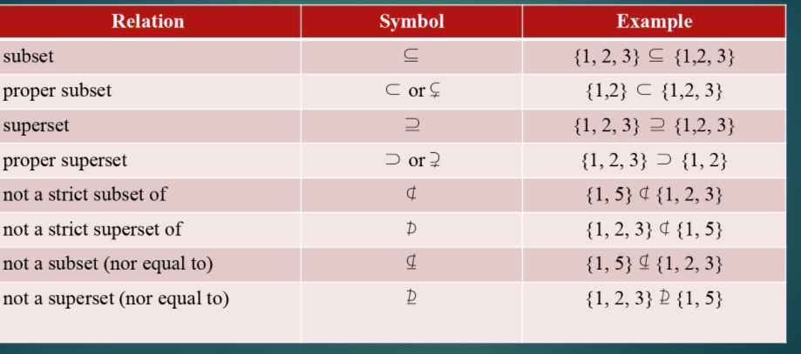

NO elements = empty set  
written as:  
A = {} or A = 0 met schuine streep er door

Union of two given sets is the smallest set wich contains all of the elements of both sets example:  
A = {1,2,3,5,8} B = {1,3,4,5,7} A U B = {1,2,3,4,5,7,8}

Intersection of two given sets is the largest set wich contains all the elements that are common to both sets example:  
A = {1,2,3,5,8} B = {1,3,4,5,7} A (omgedraaide U) B = {1, 3, 5}

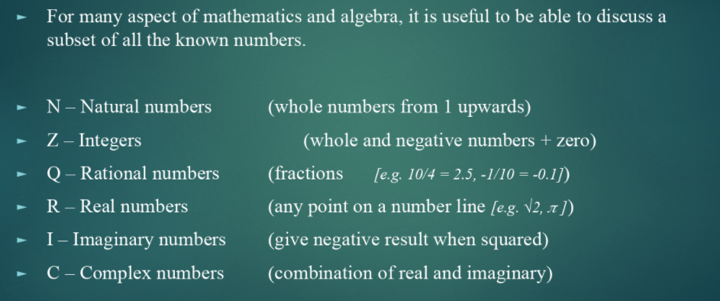

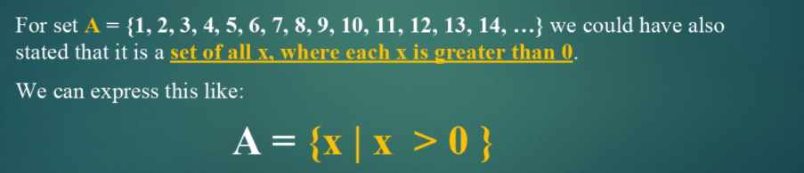

Cardinality = how many members  
Power set = a set of ALL subsets

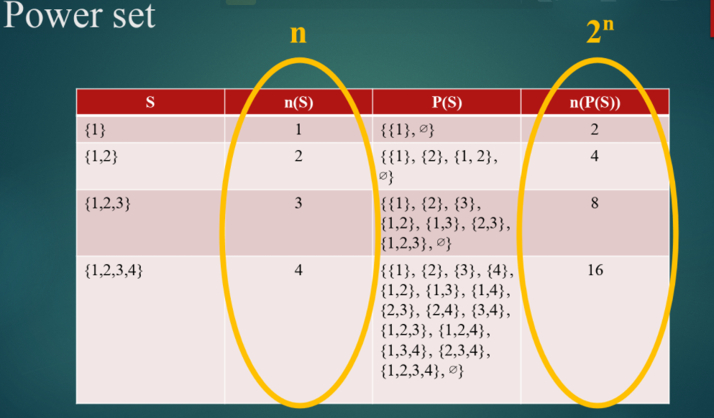

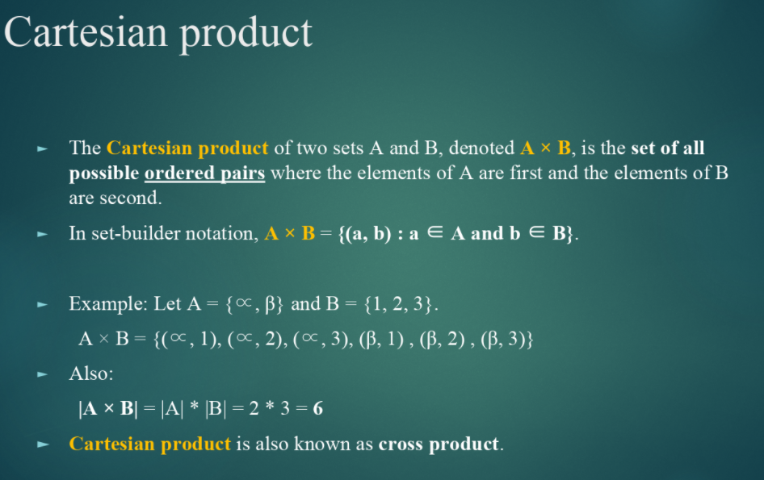

# 5.2 Sets

Zoals titel zegt gaat over sets

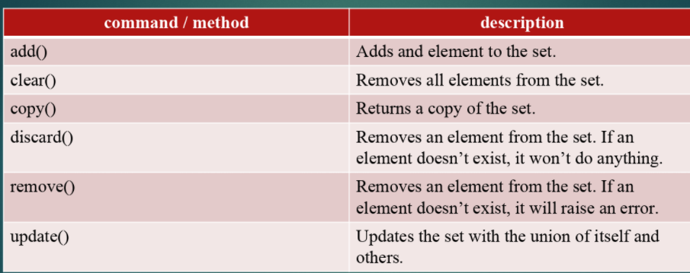

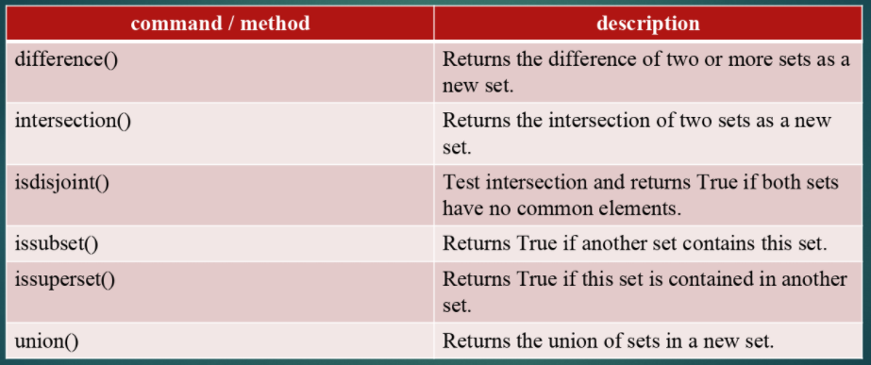

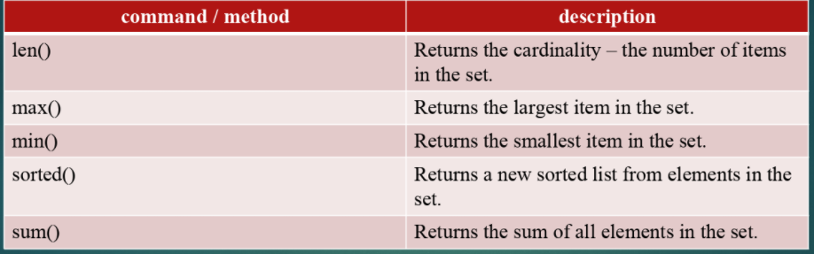

Rest van slides gaat over FOR loop + string + tuple + index

# Lesson 6.1 Problem solving with Venn diagram

Venndiagram verschil tussen U en omgedraaide U ding

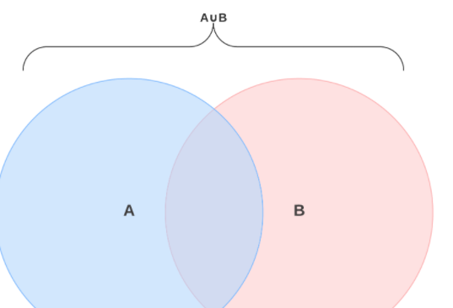U

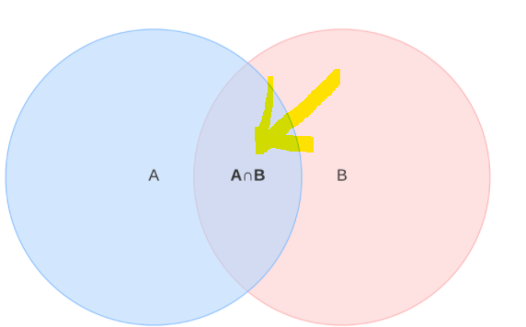Omgedraaide U

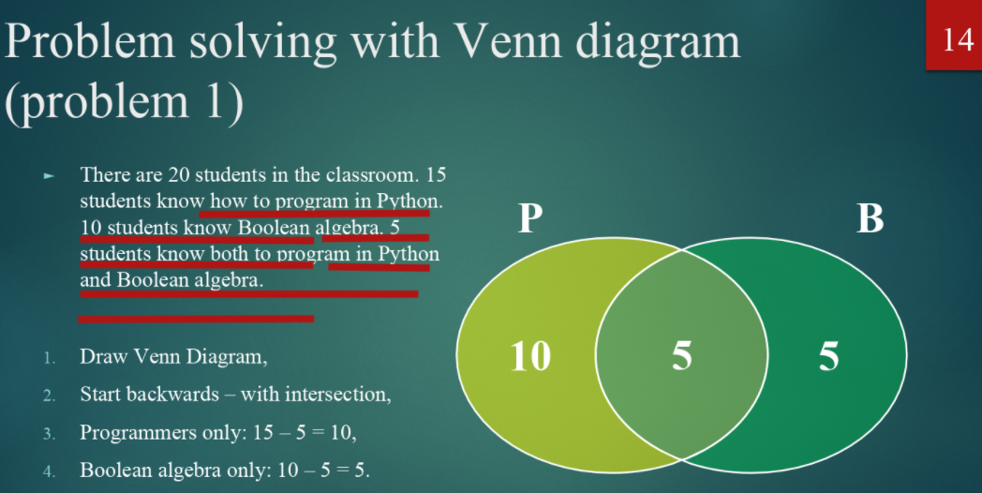

**Categorical proposition** 🡪 is a statement about the relationship between categories example:  
Fully contained 🡪 All teachers are programmers  
Partially contained 🡪 some teachers are friendly  
Completely separate 🡪 no teacher is a millionaire

Omscrhijven 🡪 some dogs are friendly  
s = dogs  
p = friendly  
some S are P  
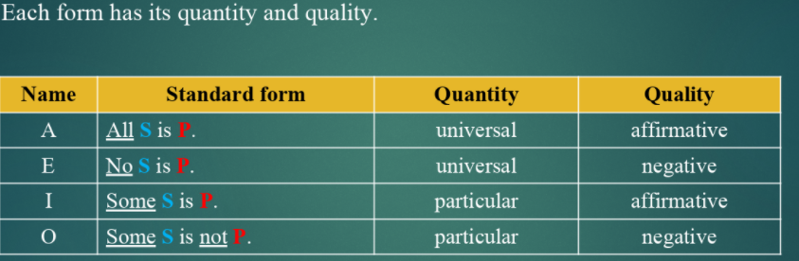  
(bedacht door aristotle (384 – 322BC) ) dit zijn vier primaire verschillende categorical propostions  
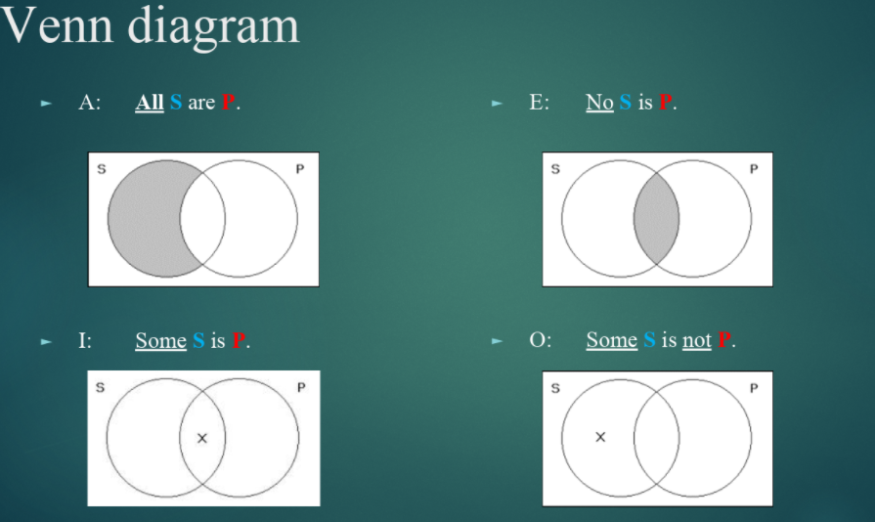  
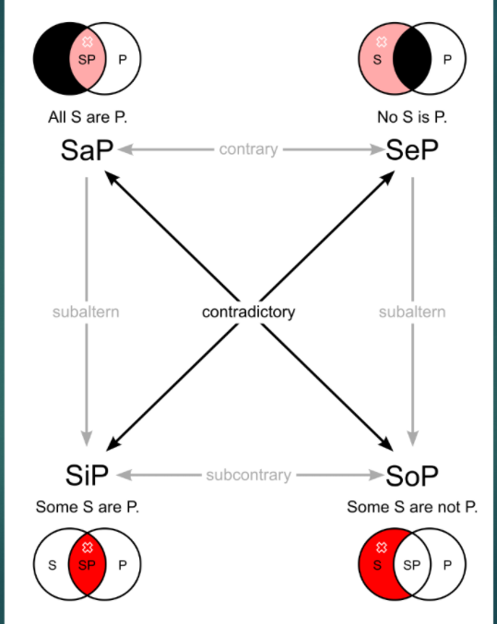

Check voor je zelf slide 32/33/34 van 6.1 Gaat over Syllogism

# 6.2 lists